**DAILY ONLINE ACTIVITIES SUMMARY**

|  |  |  |  |  |  |  |  |  |
| --- | --- | --- | --- | --- | --- | --- | --- | --- |
| **Date:** | **19-05-2020** | | | | | **Name:** | **JAIDITHYA** | |
| **Sem & Sec** | **6th B section** | | | | | **USN:** | **4AL17CS118** | |
| **Online Test Summary** | | | | | | | | |
| **Subject** | | **CGV** | | | | | | |
| **Max. Marks** | | **60** | | **Score** | | | **54** | |
| **Certification Course Summary** | | | | | | | | |
| **Course** | **ML with python** | | | | | | | |
| **Certificate Provider** | | | **cognitive class.ai** | | **Duration** | | | **3hrs** |
| **Coding Challenges** | | | | | | | | |
| **Problem Statement:** We have a Letter or a word then we need add some letters to it and need to find out shortest palindrome  Write a simple code to identify given linked list is palindrome or not by using stack. First take a Stack | | | | | | | | |
| **Status: solved** | | | | | | | | |
| **Uploaded the report in Github** | | | | | **Yes** | | | |
| **If yes Repository name** | | | | | **Daily status-19th** | | | |
| **Uploaded the report in slack** | | | | | **yes** | | | |

Online Test Details: CNSC assessment

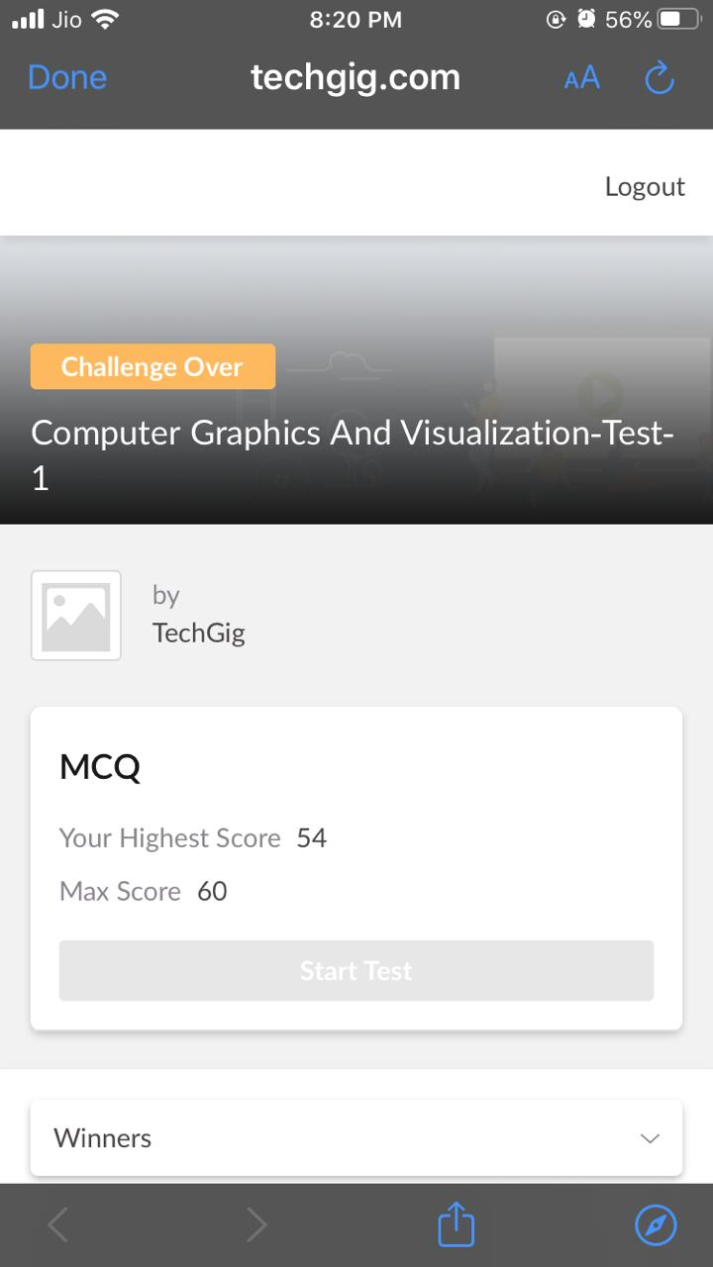

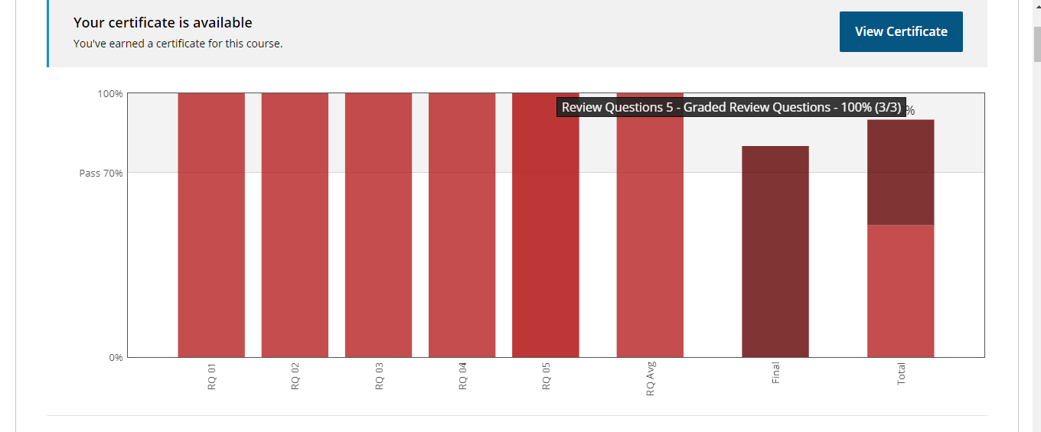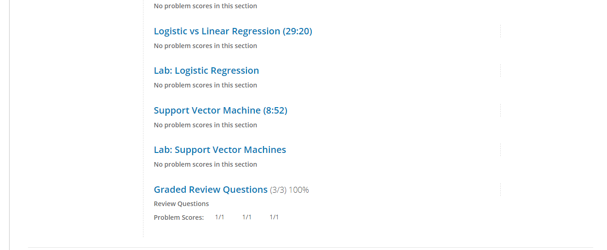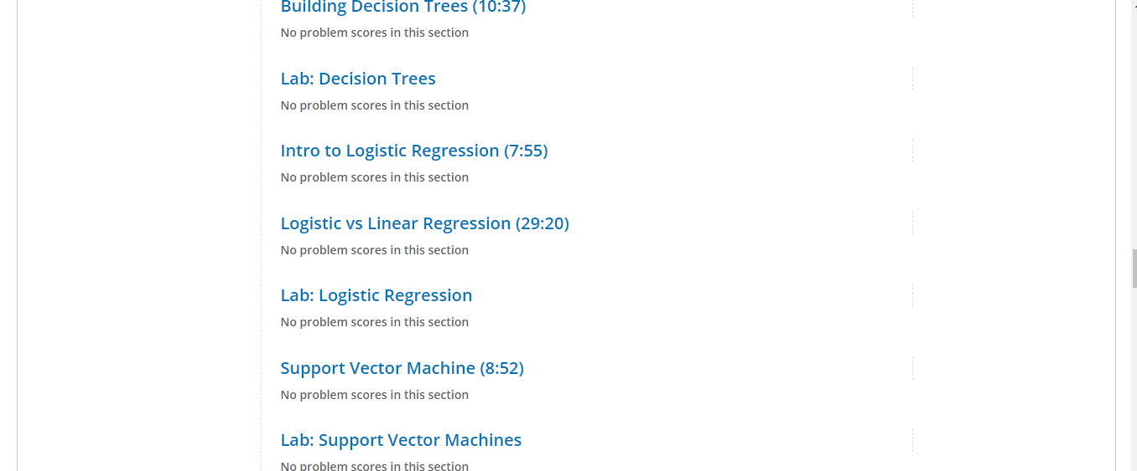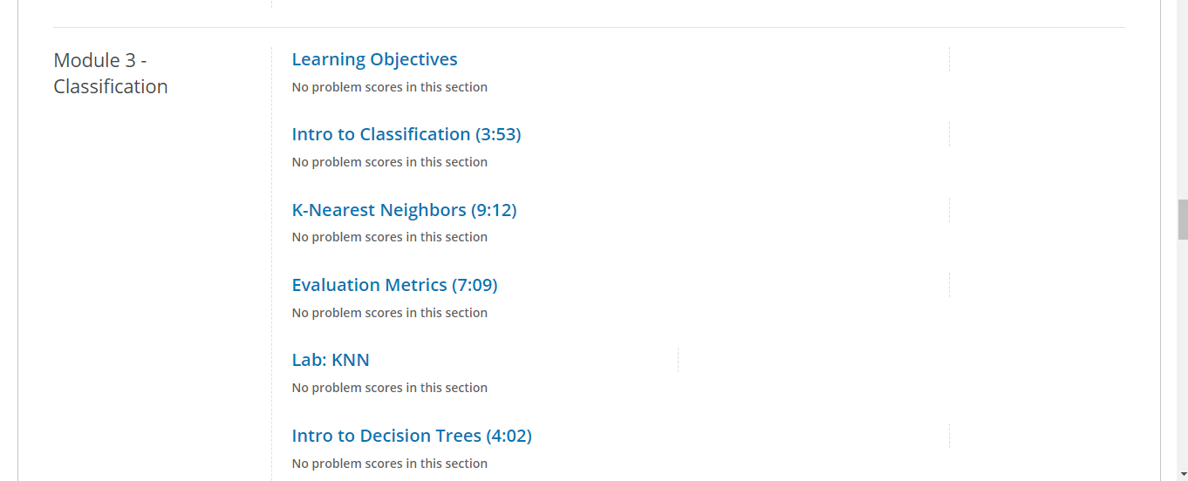

Certification Course Details: Machine learning with python course certificate for completion

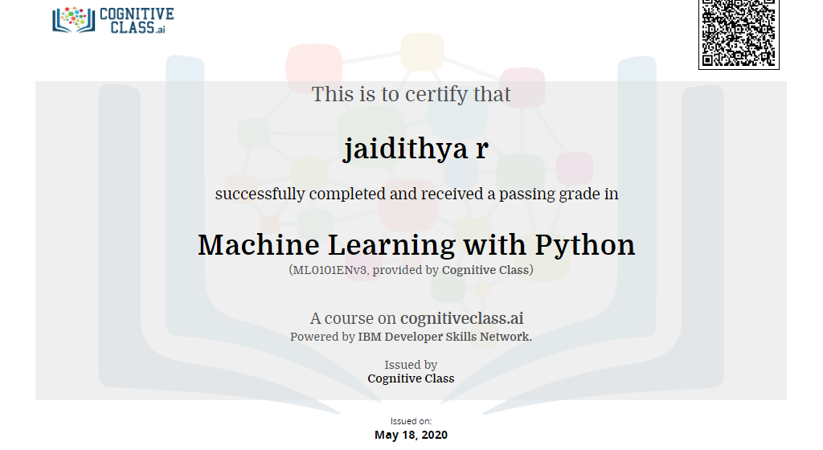

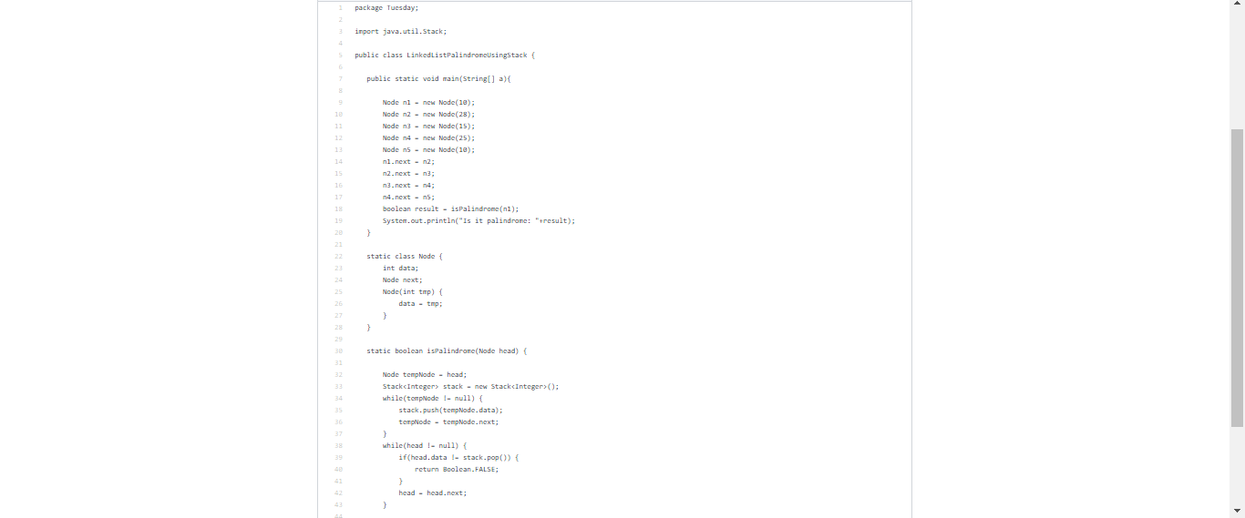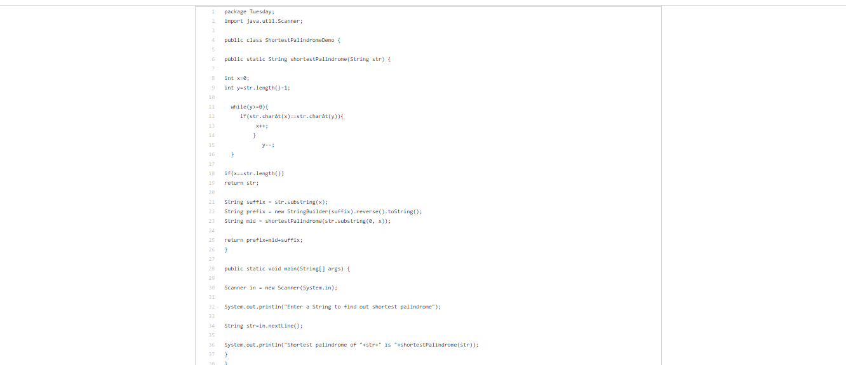

Coding Challenges Details:

Statement1-  A user will input two strings, and we find if one of the strings is a sub sequence of the other

Statement2 -We have a Letter or a word then we need add some letters to it and need to find out shortest palindrome